The Ping Pong Poggers

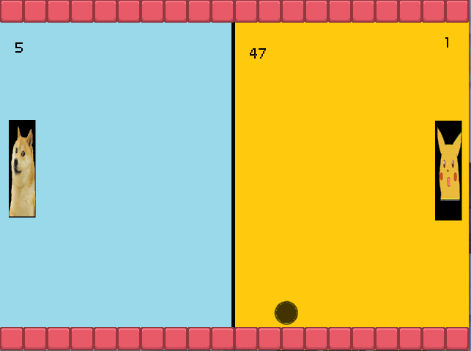

**Control Scheme**Player 1 Player 2   
W = up I = up   
S = down K = down

**Gameplay rules**

Time based Pong game where a player gets the most points before the time runs out wins the game, choosing between easy or competitive mode. Two Players are required to play this game.  
  
**Game Objects**

|  |  |
| --- | --- |
| **Stuff Added** | **Purpose** |
| Paddles 1 | Player 1 |
| Paddles 2 | Player 2 |
| Yellow Ball | Easy Ball |
| Black Ball | Competitive Ball’ |
| Title screen | Background |
| Option Screen | Background |
| Drawn Screen | Background |
| Player 1 win Screen | Background |
| Player 2 win Screen | Background |
| Main game Screen | Background |
| Boink sound | Ball Sound Effects |
| Main Game song | Title Screen Background Music |
| Game Background song | Game background song for competitive and easy mode |
| Win song | For Win Scenes |
| Draw song | For Draw Scene |
| Ball collision 1 | Ball collide with paddle 1 |
| Ball collision 2 | Ball collide with paddle 2 |
| Ball exit screen | Add points to players and spawn ball when ball leaves screen |
| Ball movement | Ball mechanics for the game |
| Ball exit screen Easy mode | Add points to players and spawn ball when ball leaves screen for easy mode |
| Ball Spawn | Spawn ball |
| Paddle movement 1 | Paddle 1 player movement |
| Paddle movement 2 | Paddle 2 player movement |
| Titles | Red blockers |

**Gameplay Features**

Time Countdown  
- added a countdown timer for the game. When timer runs out, the player who has the most points wins the game if an equal amount of points between both players draw will be rewarded.  
  
GameModes

- added 2 gamemode which are competitive and easy modes. Competitive has faster balls and gameplay catered for players who love fast paced games. While easy mode has a slower gameplay and pace.

**Pseudocode**  
**Timer Countdown for competitive and easy Scene**

When created

* Set timer to 60
* Create ball at x, y at font
* Play background music
* Set volume to low
* Set player 1 score to 0
* Set player 2 score to 0

Every N secs

* Do every 1 second   
  Decrement time by 1

When updating

* If timer less than 0
* If player 1 score is greater than player 2 score switch scene to player 1 win
* If player 2 score is greater than player 2 score switch scene to player 2 win
* If player 1 = player 2 score switch scene to Draw Scene

When drawing

* Draw player 1 score at x, y
* Draw player 2 score at x, y
* Draw time at x,y

**GameModes option scene**

When created

* Play background music

When updating

* If button 1 is down switch scene to Easy Mode Scene, fade out background sound
* If button 2 is down switch scene to Competitive Mode Scene, fade out background sound

When drawing

* Draw button 1 for Easy Mode at x,y
* Draw button 2 for Competitive at x,y